**SERVICE MANUAL**

**Flow Diagram**

*Head Clerk*

**1. Initiated the application for cancellation of flat.**

API-1 Call to Get data

**Estate Officer**

**2. Approve and generated termination letter**

API-2 call to update the database

*Head Clerk*

END

**LOGIN WITH DEFINER LOGIN AND SELECT CREATE NEW SERVICE.**

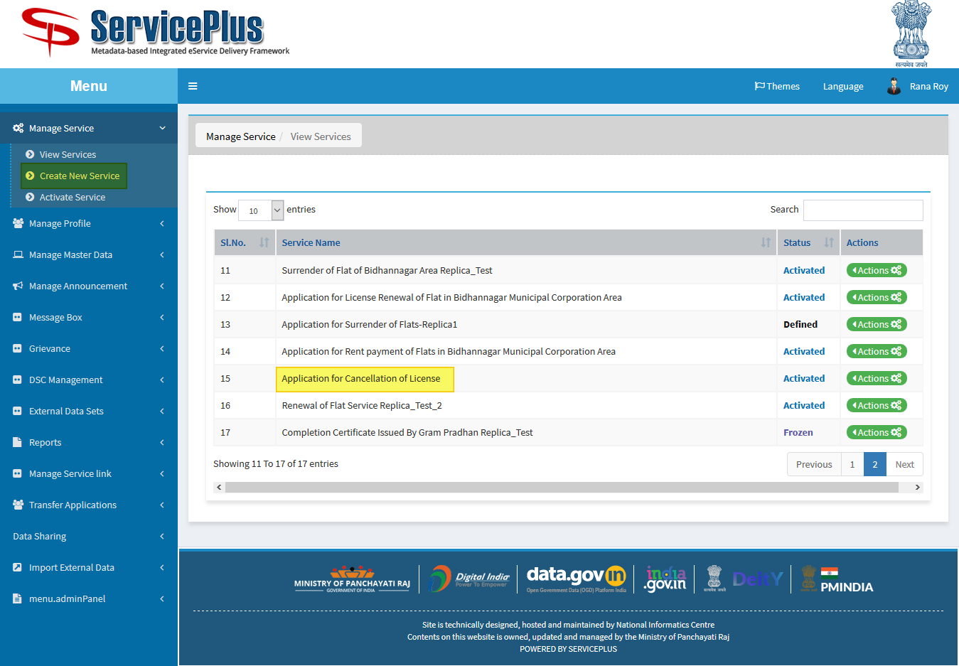

1. **SELECT DEFINITION AND FILL ALL DETAILS.**

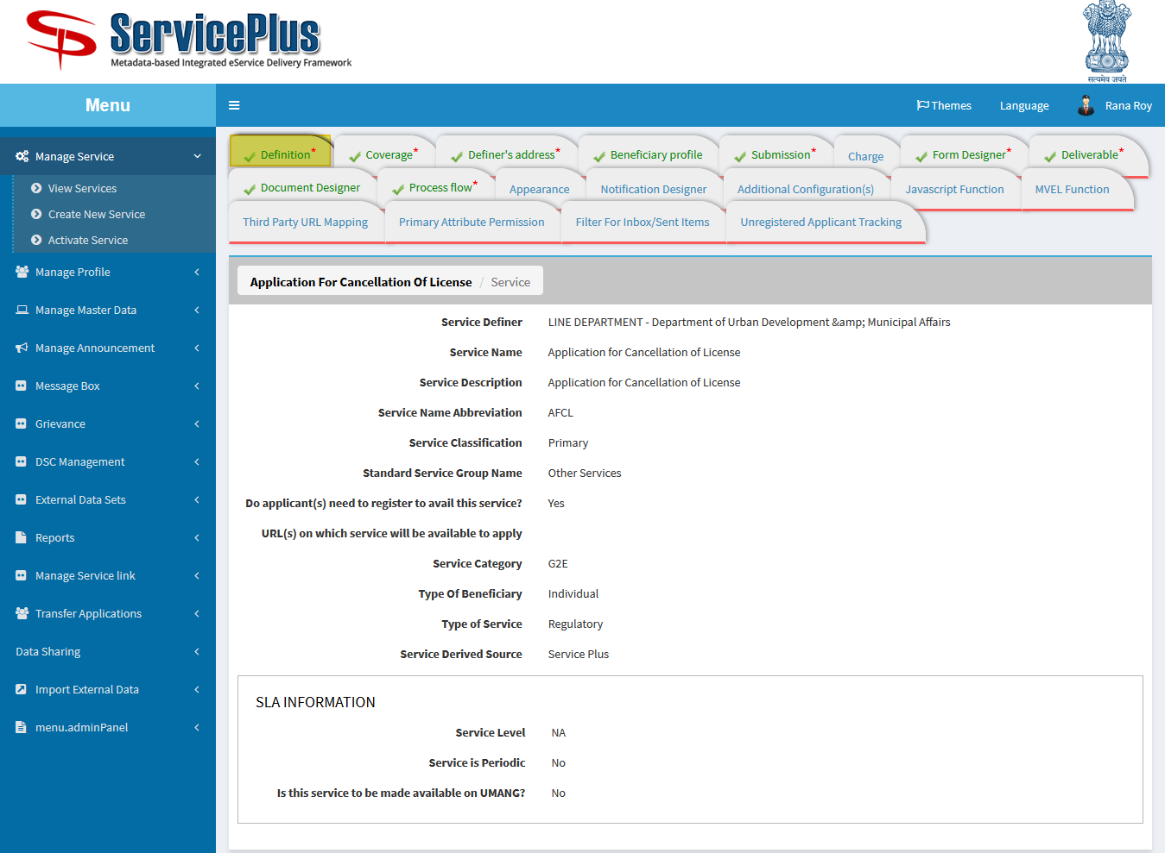

1. **SELECT COVERAGE AND SELECT THE LIST OF SERVICE UNITS.**

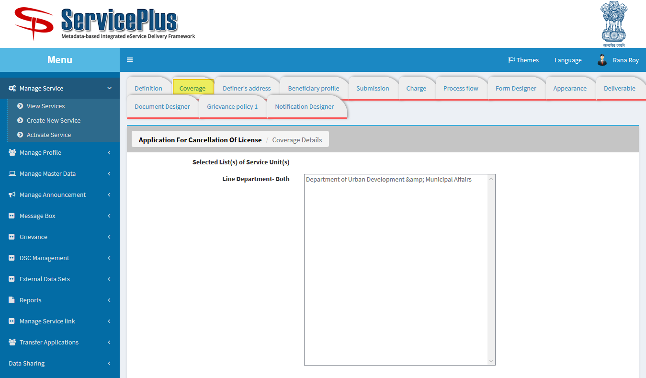

1. **FILL DEFINER’S ADDRESS.**

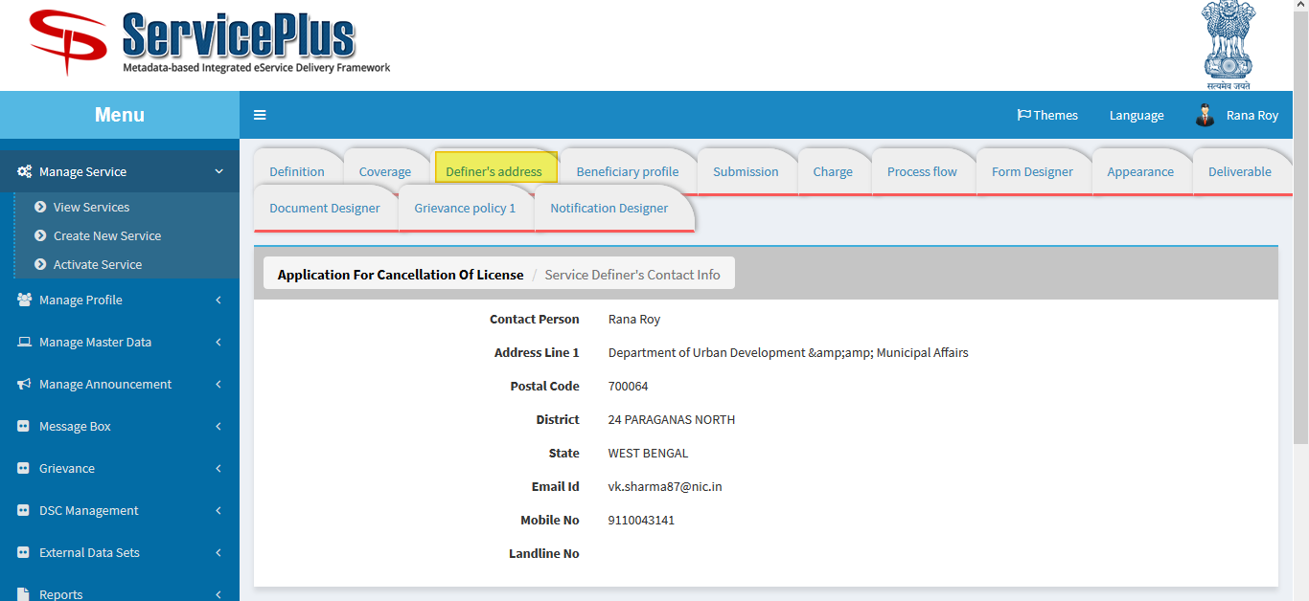

1. **BENEFICIARY PROFILE FOR WHO CAN APPLY.**

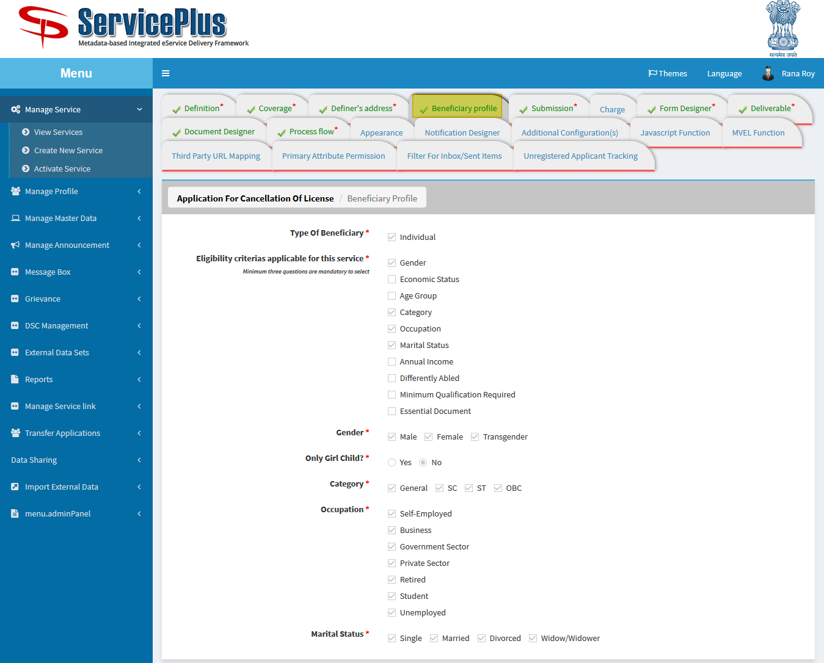

1. **SUBMISSION AND ENCLOSURES REQUIRED TO FILL UP THE FORM.**

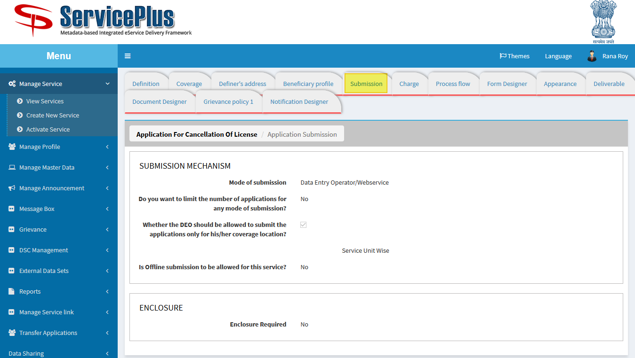

1. **FORM DESIGNER: HERE NEW TEMPLATE FOR FORM CAN BE DESIGNED, MODIFIED OR PREVIEWED.**

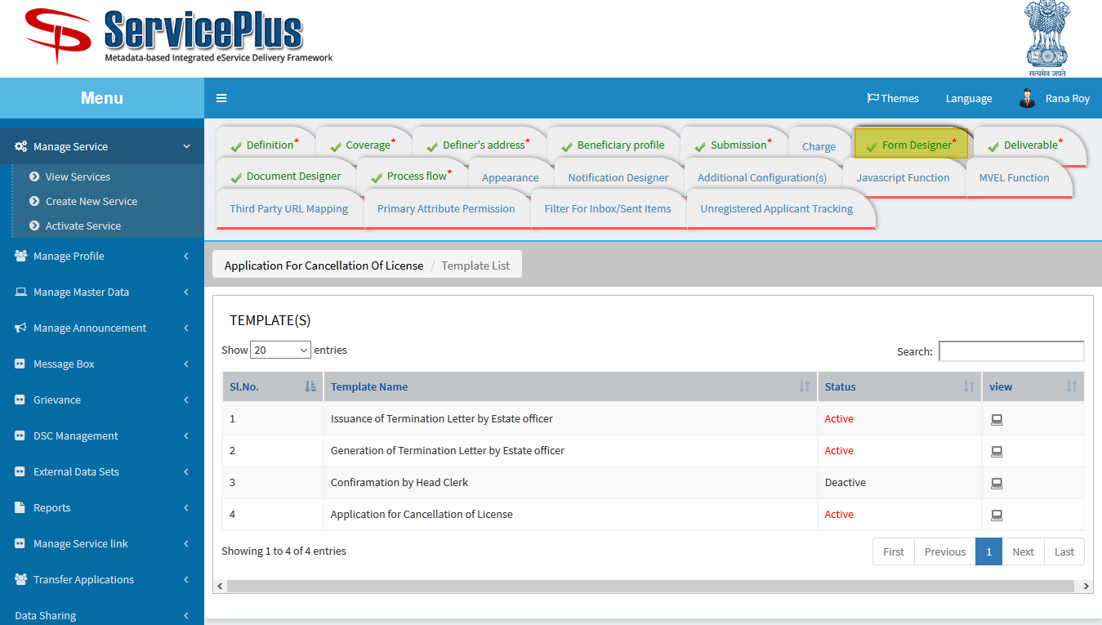

**Application for Cancellation of License**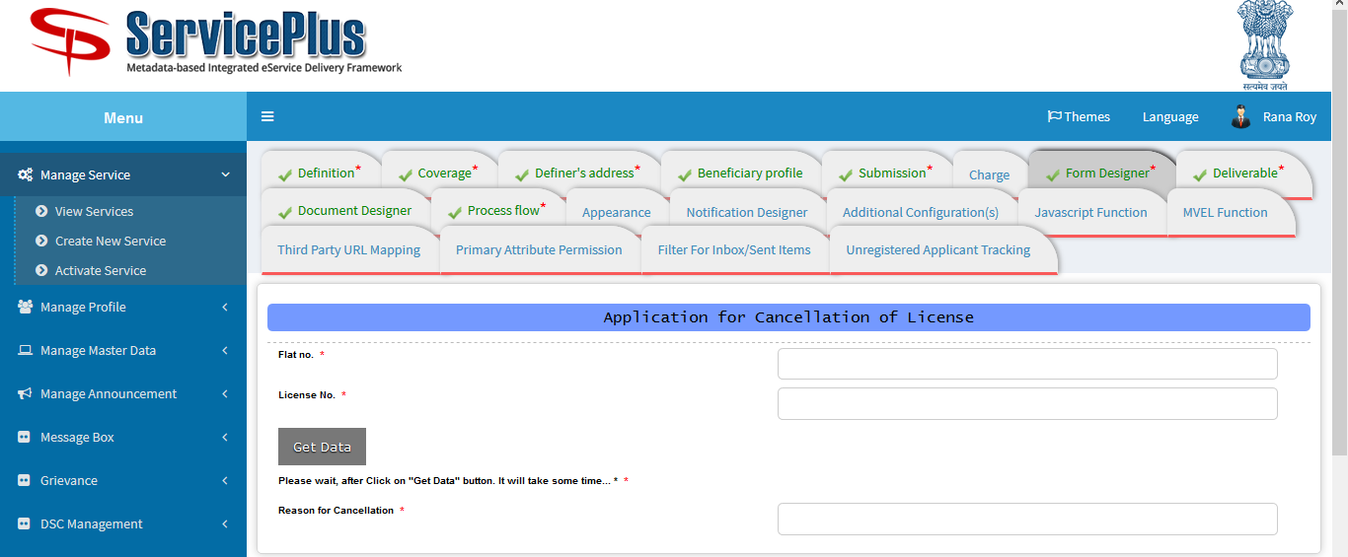

**Issuance of Termination Letter by Estate officer**

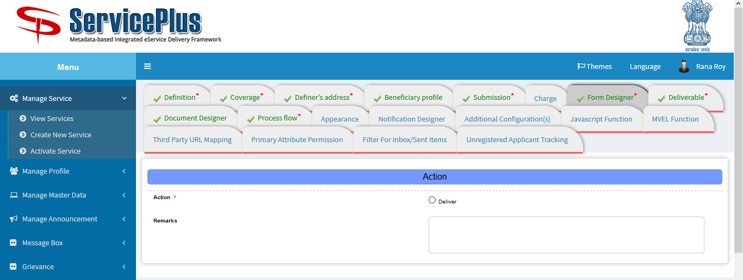

**Generation of Termination Letter by Estate officer**

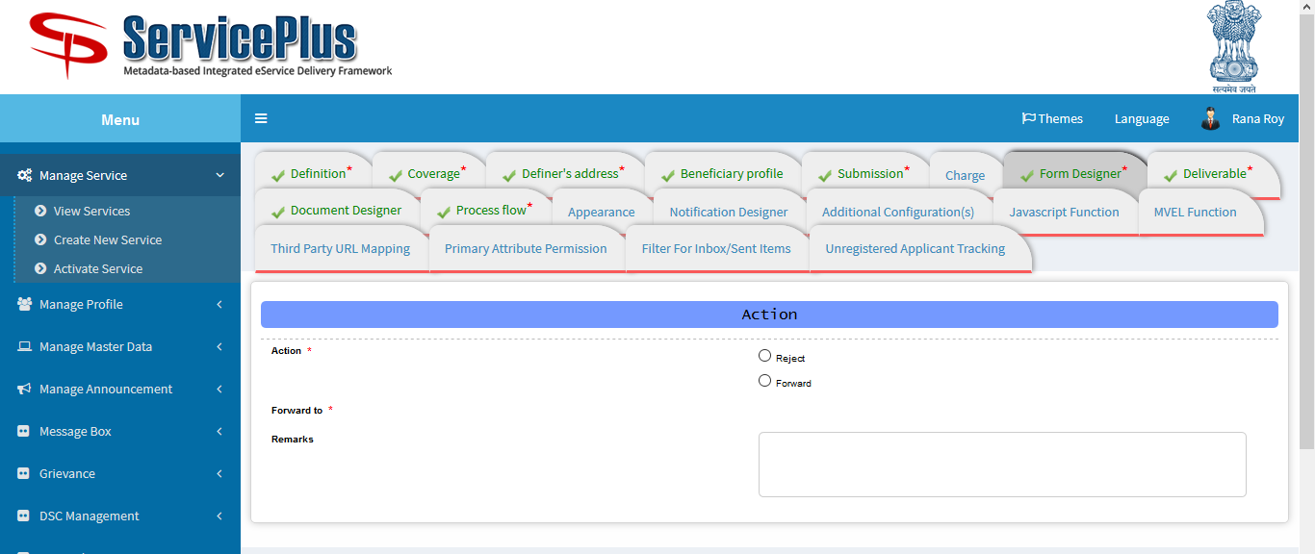

1. **DELIVERABLE: HERE CONFIGURATION IS DONE FOR APPLICATION WHEN IT’S DELIVERED.**

**CERTIFICATES AND BARCODE COULD BE SELECTED TO BE IMPRINTED ON CERTIFICATES.**

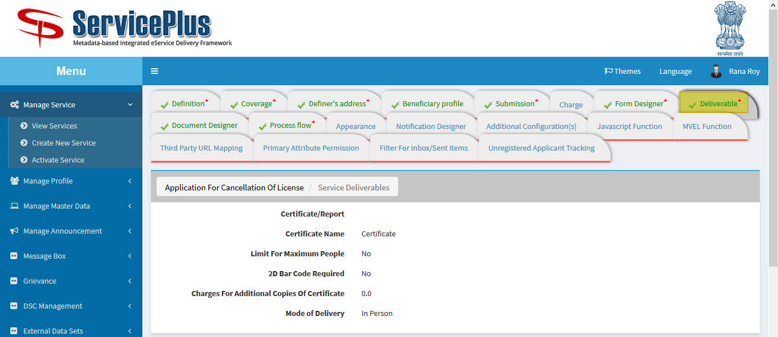

1. **DOCUMENT DESIGNER: DOCUMENT CAN BE DESIGNED HERE.**

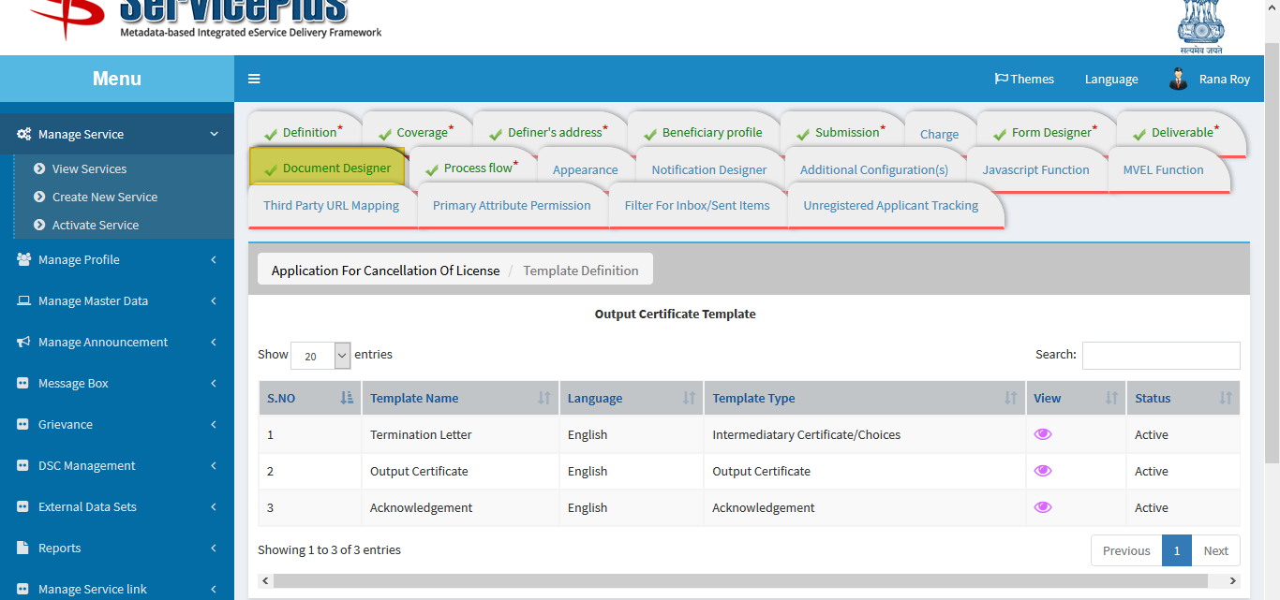

1. **PROCESSFLOW: ASSIGN DEPARTMENT/DESIGNATON FOR DEPARTMENT PURPOSE WHO IS GOING TO TAKE ACTION.**

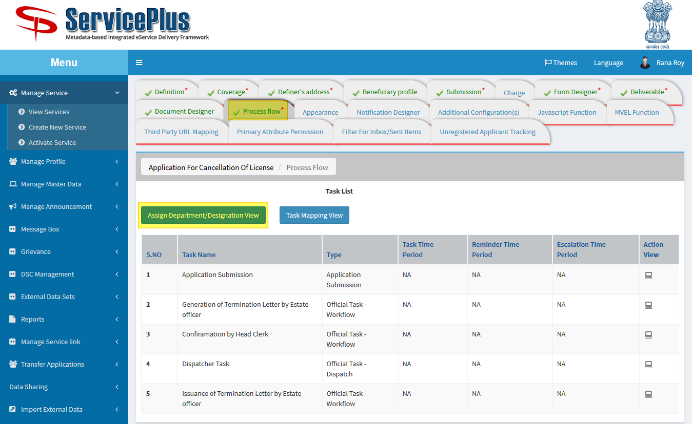

**ASSIGN DEPARTMENT/DESIGNATION VIEW**

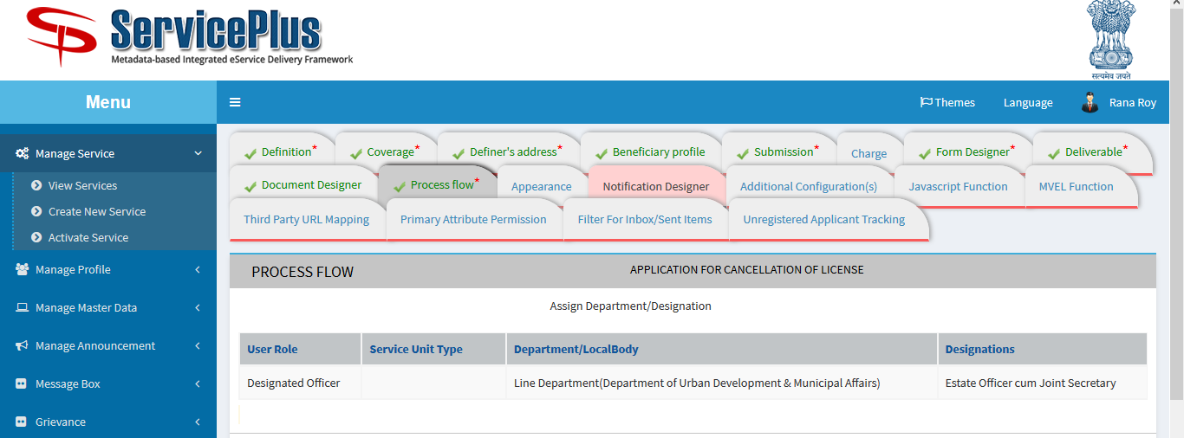

1. **TASK MAPPING VIEW: HERE TASK MAPPING COULD BE SEEN.**

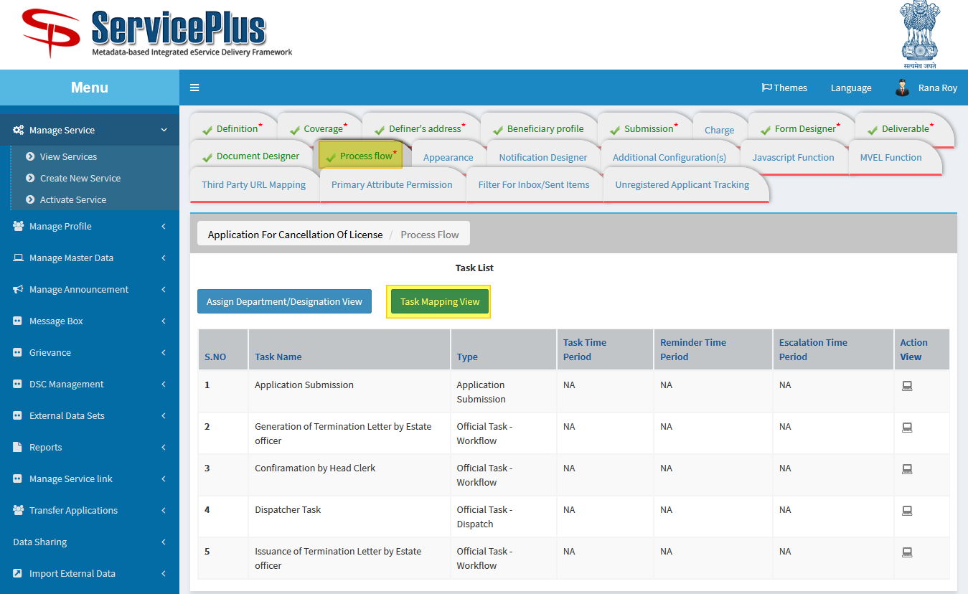

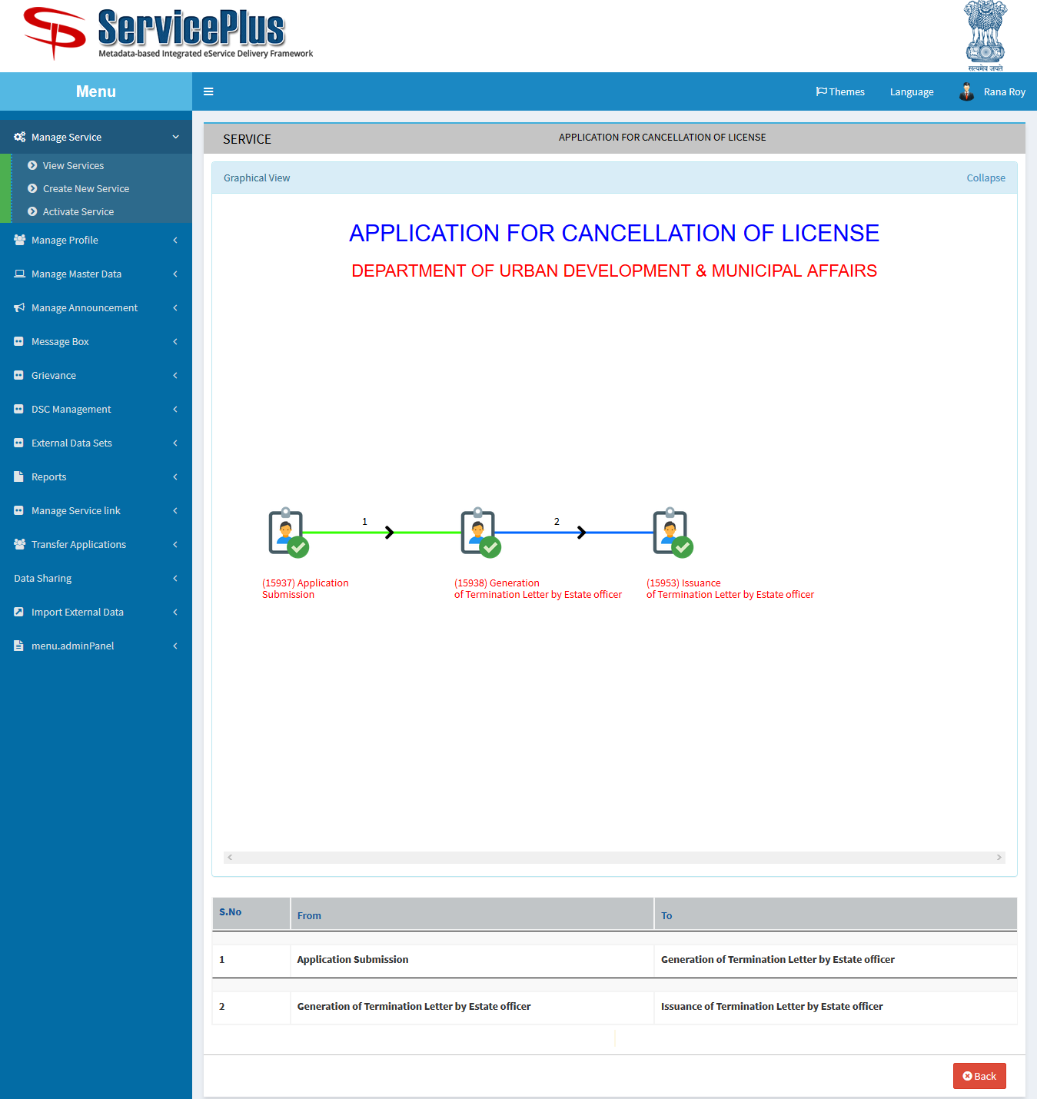

1. **NOTIFICATION DESIGNER: DESIGN AND ACTIVATE NOTIFICATION WHILE APPLICATION OR ANY OF THE ACTIONS.**

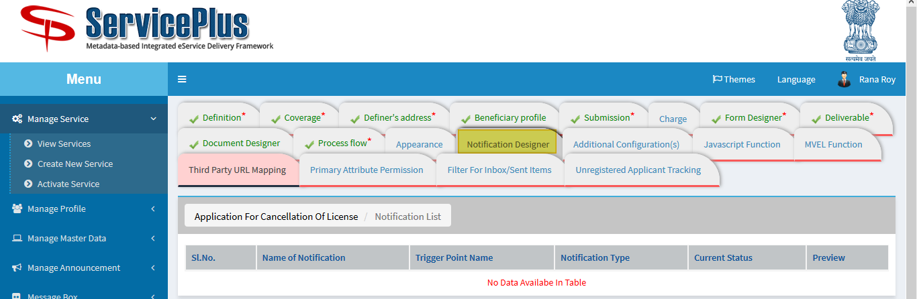

1. **JAVASCRIPT FUNCTION: TO MAKE FORM DYNAMIC HERE JS FUNCTION CAN BE ADDED.**

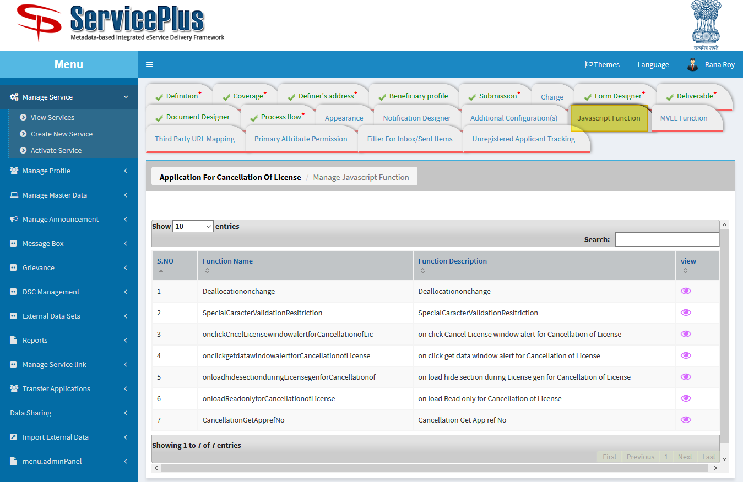

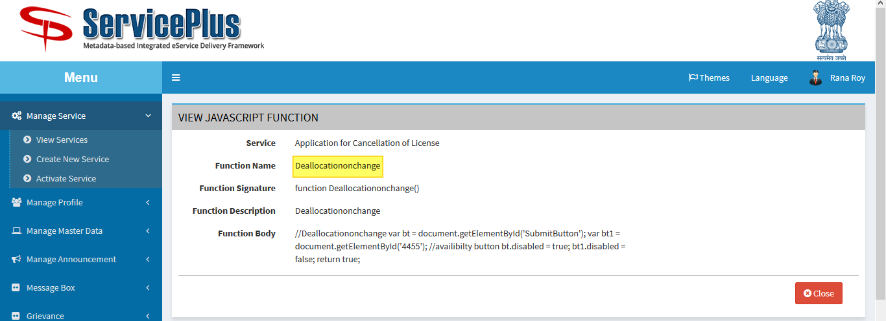

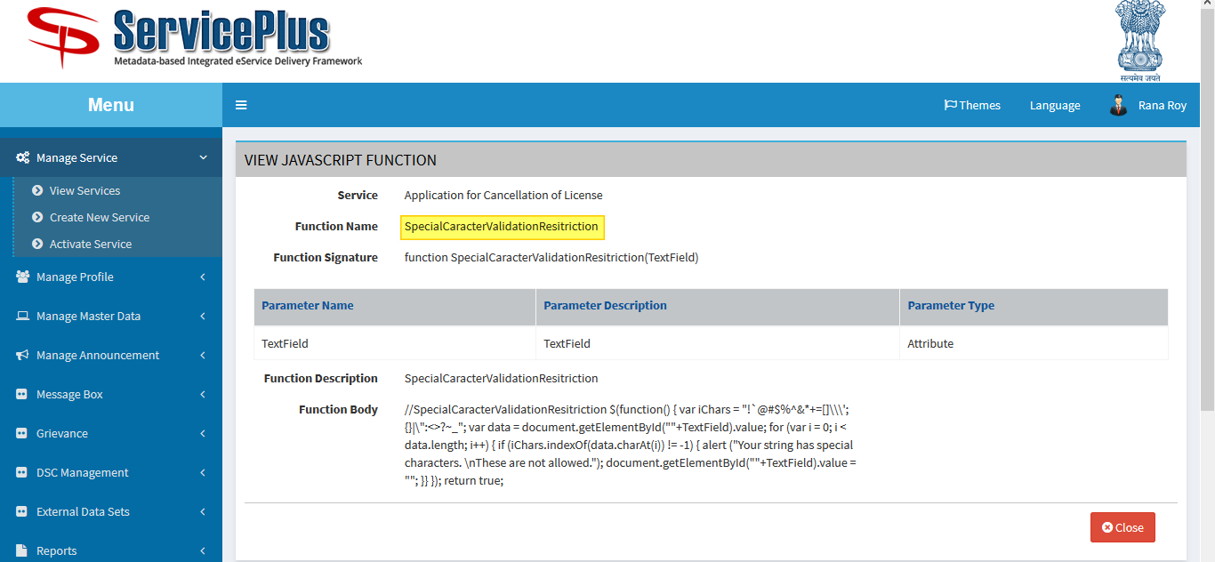

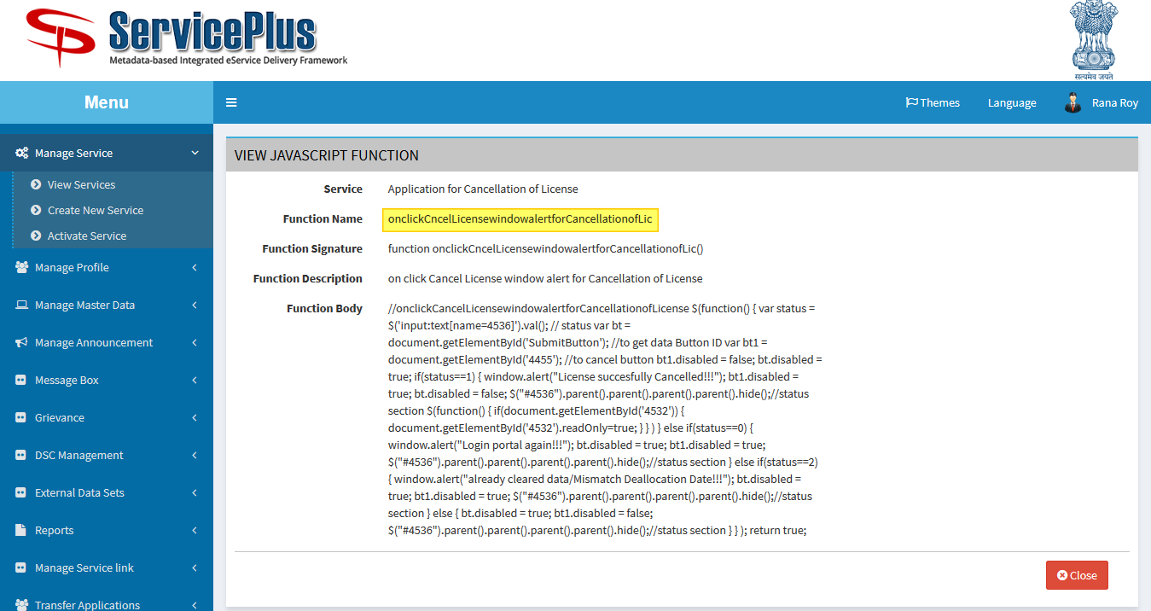

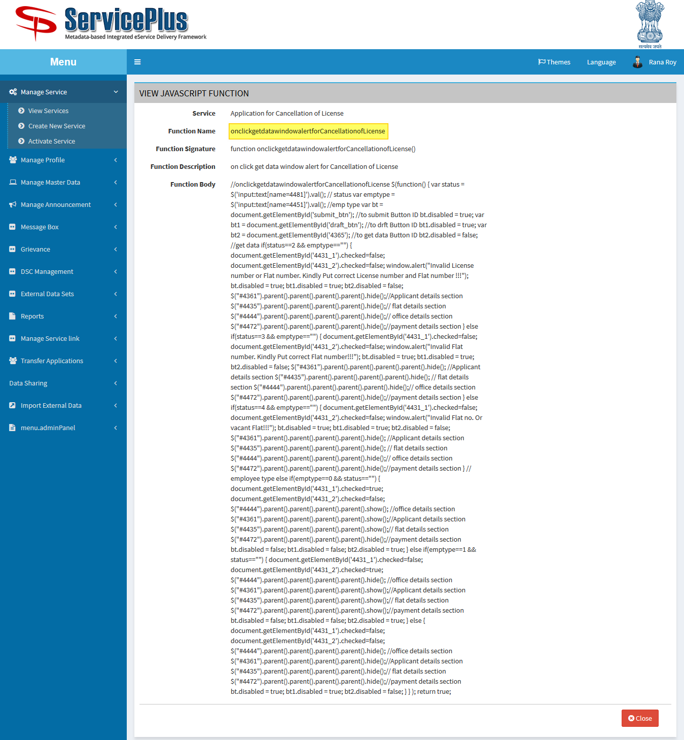

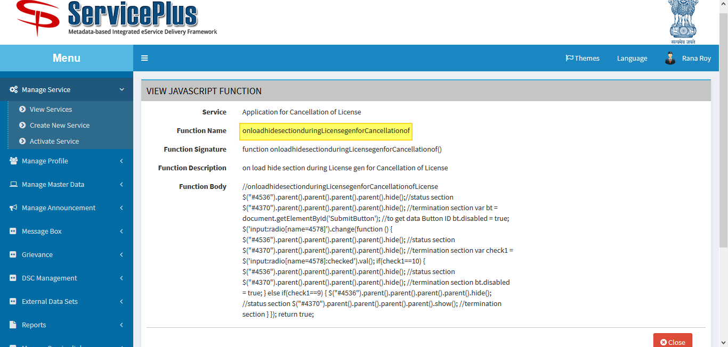

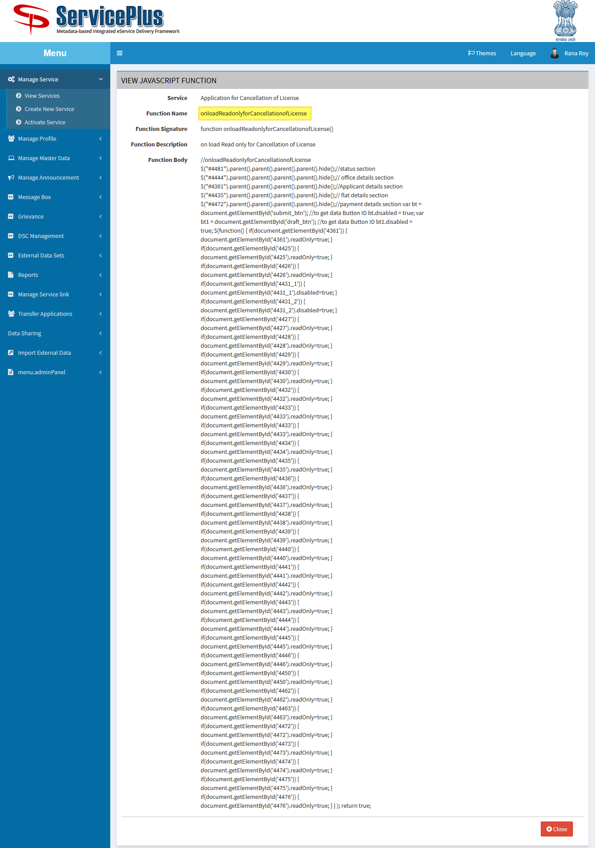

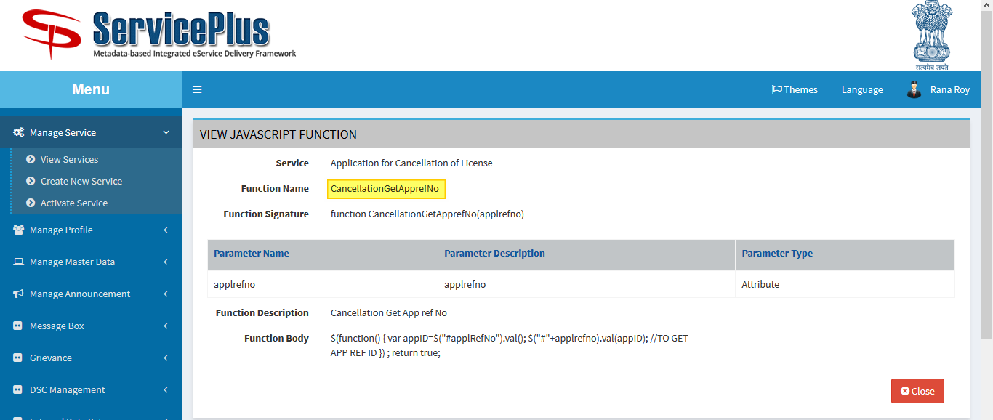

1. **MVEL FUNCTION**

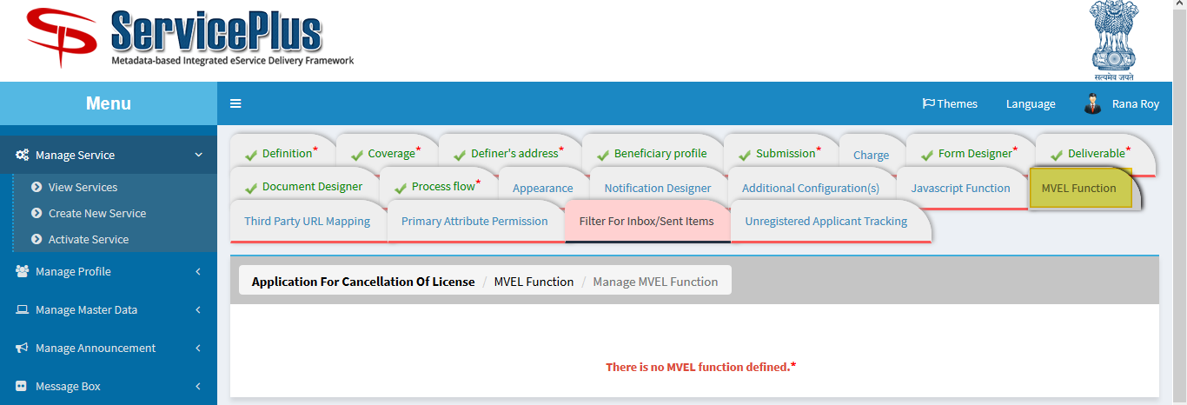

1. **UNREGISTRED TRACKING**

